PAVILION THEATRE STUDIO SPACE AWARD 2020
OPEN CALL
APPLICATION FORM
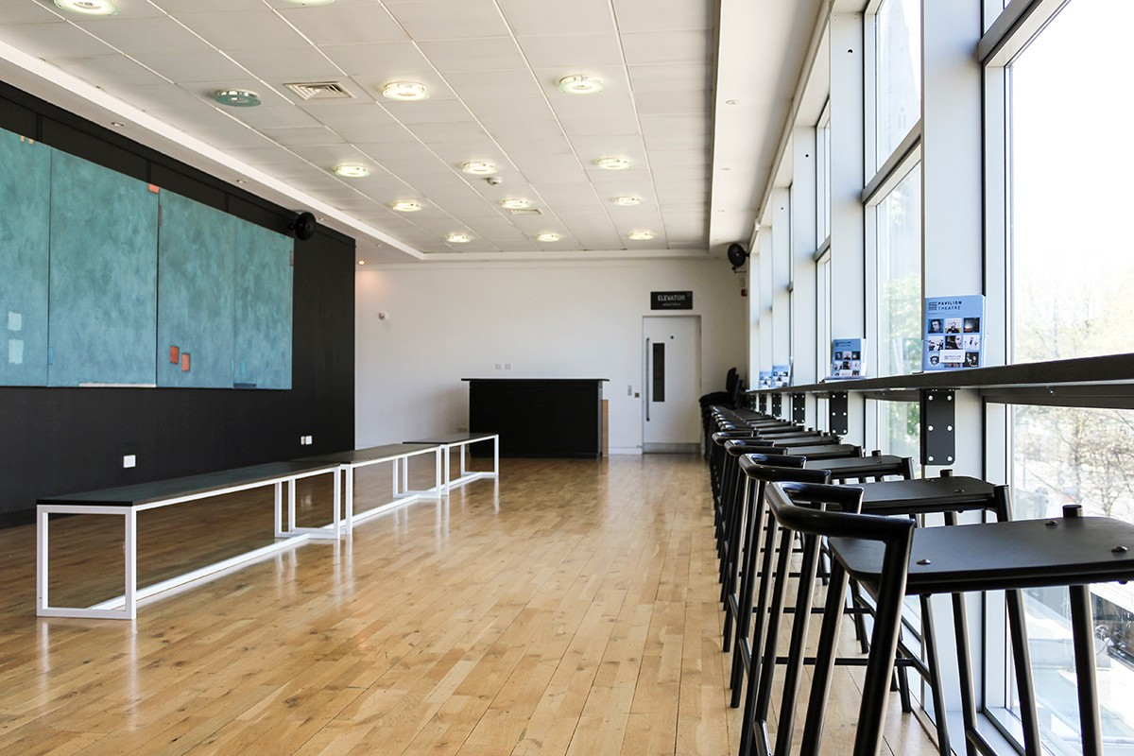

Pavilion Theatre's Gallery Space © Dónal Kennedy
The Award
The Pavilion Theatre Studio Space Award is intended to enable artists and makers in theatre and dance to research and develop new work over a period of up to four weeks, through the provision of a dedicated work-space in Pavilion Theatre’s Gallery space.

Applicants may apply for a minimum of two weeks and a maximum of four weeks time-slot, to fall from 6 January 2020 to 4 December 2020, as available. The space is offered free of charge and does not need to occur in consecutive weeks. It is available from Monday to Friday. A member of Pavilion Theatre’s team will be assigned as liaison to connect awardees to the programme of Pavilion Theatre

Based in Pavilion Theatre’s Gallery space, the Award provides a free, good-sized, bright work-space at Pavilion Theatre overlooking Marine Road and Dún Laoghaire Harbour. The space can accommodate individuals and small companies. It is not suitable for sets or large props.

The Theatre is two minutes from Dún Laoghaire Dart station and adjacent to many coffee houses, restaurants and shops. The space has wireless broadband.

Terms & Conditions
Successful proposals are likely to attend carefully to the congruence of the work proposed with the nature of Pavilion Theatre’s programming and the work proposed may be of interest to Pavilion Theatre in terms of future co-commissioning or co-producing. A condition of funding will be appropriate acknowledgment of Pavilion Theatre in any work produced or presented.

Awards will be made at the discretion of Pavilion Theatre and specific terms and conditions will be defined for each successful application to include:
- communications/liaison with Pavilion Theatre
- scheduling/conditions of time and access to space
- credits and acknowledgement of Pavilion Theatre.

Criteria:
Applications will be assessed according to the following criteria:
(i) Eligibility of Application – the application form is completed in appropriate detail and is submitted on time
(ii) Quality and Nature of research and development proposal and relevance to both the artist’s development of practice at that time and relevance for Pavilion Theatre as per terms & conditions above.
(iii) Track Record of Artists Involved – the achievement to date of the individual maker or group of artists making the proposal; evidence of previous collaboration in the case of groups
(iv) Appropriateness of space (of this size) to the needs of artists and makers
(v) Feasibility of the Proposal – demonstrable evidence of the following:
a. that an award, if made, will allow for the significant development / completion of the proposed project or piece of work
b. a credible project time-frame and budget
c. capacity to communicate and dialogue with Pavilion Theatre or its representatives
d. evidence of support including for example letters, references, referees.

Quotes from previous Awardees
“The award was essential to me in re-drafting my play. This is my first play as a solo writer and it has been incalculably valuable that I was given a space in Pavilion Theatre in which I could both work with the actors and also use as a space in which to write. I could not have progressed without this support and on a personal level, without the encouragement and generosity I received” - Janet Moran, actor and playwright

“We spent one week in Pavilion Theatre's Gallery space, developing ideas for a new children's show. We presented a work-in-progress in the Gallery at the end of the week, along with a talkback session. This was a wonderful opportunity for us to test ideas and to receive feedback for further development in an environment that favoured experimentation and welcomed conversation between us and test audiences” - Mollie Molumby, Bombinate Theatre

“I found the space more than suited to my needs: a large, comfortable workspace complete with a desk, Wi-Fi access and a beautiful view of the old Town Hall” - Cathal McGuire, theatre-maker

Privacy (General Data Protection Regulation GDRP)
The purpose for processing your data is to process your application for a Pavilion Theatre Studio Award 2020. This information you provide will be assessed by a panel made up of staff of Pavilion Theatre and external invited arts specialists.

Your information will be retained for five years if you are granted an award and for one year if not granted an award. If you do not furnish the personal data requested, Pavilion Theatre will not be able to process your application.

Schedule
Closing date for application: 5pm 15 November 2019
Selections made: Week of 18 November 2019
Awards begin: Week of 6 January 2020 until 4 December 2020

- ARTIST(S) CONTACT DETAILS

Name and role of lead Artist:
Art Form:

Organisation:

Names of other collaborators (if relevant):

Address:

Mobile:

Email:

- PROPOSAL
- 3 bullet points of your proposal
(Max 150 words)

2. Ideal time-frame (While efforts will be made to suit the ideal time-frame, this cannot be guaranteed as part of an awardee’s offer)
Number of weeks being sought:

Ideal Dates:

Alternative Dates:

3. Detailed Description of the research and development you would like to undertake and an explanation of why the use of a space like this is important to your practice at this time
(Max 500 words)

4. Background and achievements to date
(Max 300 words)

5. List of relevant images/supplementary/links material provided to include CV (s) in pdf.
(Max 6 pages)

Deadline for receipt of applications is 5pm 15 November 2020
No late applications will be accepted.

SEND COMPLETED PROPOSAL AND PDF SUPPLEMENTARY MATERIALS TO:

Niall O’Connell Operations Manager
Email: niall@paviliontheatre.ie

