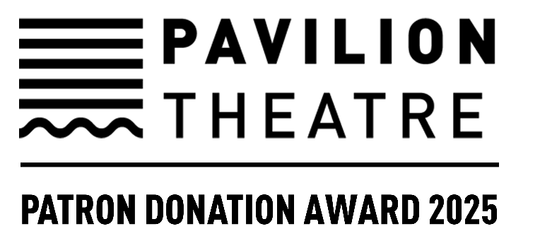

**PAVILION THEATRE PATRON DONATION AWARD 2025**

**OPEN CALL**

**COMPANIES, COLLECTIVES, PRODUCERS, CURATORS,  
PROGRAMMERS, VENUES, FESTIVALS**

**THEATRE | DANCE | MUSIC | OPERA | LITERATURE | PODCASTING**

**Funding Available Per Award:** Up to a Maximum of €30,000

**Deadline:** Friday 8 August 2025, 5pm

**About Pavilion Patron Donation Award**

Pavilion Patron Donation Award is a performance-based award to co-commission and co-produce ambitious main stage works, with the intention that these will be fully presented by the end of the award period (September 2027). Awards of up to a maximum of €30,000 are available for work by established companies, collectives, producers, curators, programmers, venues and festivals. Proposals are invited from those seeking to develop or produce either new work or revivals of existing work/productions. We welcome unique offerings, new collaborations and, ultimately, great art to engage with a wide audience. This could also include festival proposals, artists moving into different artforms or interdisciplinary projects.

We’re seeking work that is:

* Aligned with our mission to present main stage work of the highest artistic merit (Pavilion Theatre Strategy 2025-2028)
* Presented by those with a proven track record
* Compelling to Pavilion Theatre’s audience and scale (a 324-seat venue)
* Committed to presenting at Pavilion Theatre, with strong touring potential

Recipients of previous Pavilion Patron Donation Awards include: Ali Hardiman, Bombinate Theatre, Branar Theatre Company, CoisCéim, Danielle Galligan and Gavin Kostick, Dead Centre, Janet Moran, Landmark Productions, Lords of Strut, Luke Murphy, Replay Theatre Company and Sonya Kelly, to name a few.

**Who Can Apply**

Applicants should be:

* Established companies, collectives, producers, venues and festivals working in theatre, dance, music, opera, literature and podcasting with a track record of excellence
* Developing major projects for stage-based performance, live events or festival proposals
* Based in Ireland

Previous successful applicants are eligible.

**Key Dates**

* **Application Deadline**: Friday 8 August 2025, 5pm
* **Outcome**: Applicants will be informed of the outcome by Wednesday 27 August 2025
* **Award Work Dates:** September 2025 – September 2027

**Funding Conditions**

Funding is subject to:

* A contractual engagement and funding agreement with Pavilion Theatre
* A mutually agreed credit and acknowledgment of Pavilion Theatre’s support in all relevant materials
* A progress report of the work supported
* Submission of a testimonial

Please note that the award cannot be used to purchase or rent equipment.

**Assessment Criteria**

Proposals will be assessed based on the criteria below.

1. **Eligibility**

* The application is complete and submitted on time.
* A maximum of two applications can be made per lead applicant.

1. **Quality & Nature of Proposal**
   * The project aligns with the aims of the Patron Donation Award: ambitious, original, audience-

focused work that will be fully presented by the end of the award period (September 2027).

* + A named producer is required, either working independently or in collaboration with other artists, venues, festivals or funders. Co-funding is welcome.
  + Alignment with Pavilion Theatre’s Strategy ([Pavilion Theatre Strategy 2025-2028](https://www.paviliontheatre.ie/content/files/Pavilion_Theatre_Strategy_2025-2028_Web.pdf)).

1. **Public Engagement**

* Strong potential to connect with Pavilion Theatre’s audience.
* Strong touring potential.

1. **Track Record**

* Proven achievements of the applicant(s) involved.

1. **Feasibility**
   * Evidence that the award will significantly support the project’s development and future production.
   * Realistic timeframe and budget.
   * Clear capacity to deliver and communicate with Pavilion Theatre.

**Further Details**

No correspondence can be entered into during the process of application or selection. No late applications will be accepted. Decisions are final and made in a competitive context. This will be our only Pavilion Patron Donation Award callout for 2025.

Pavilion Patron Donation Award is made possible by the generous donations of Pavilion Theatre’s loyal patrons.

**APPLICATION FORM**

**Details of Primary Contact (for communication of outcome)**

|  |  |
| --- | --- |
| Name |  |
| Address |  |
| Email |  |
| Phone |  |
| Website / Social Media Links |  |

**Indicate the art form(s) that best describes your proposal**

Theatre  Opera

Dance  Literature

Music  Podcasting

**Application Checklist**

|  |  |
| --- | --- |
| I have completed all sections of the form below within the word limits. |  |
| I have attached CVs of all named artists/collaborators involved (no more than 3 pages each). |  |
| I have attached PDF copies of letters or emails confirming commitment to the project from all named collaborators (including a required Producer) and, where applicable, from prospective partners involved in future production/presentation. |  |
| I have included working online links to supporting material in Part 2 of this application form **or** where online content is not available, I have attached one single PDF of supporting material (maximum 6 pages). Hard copies of supporting material are not acceptable. |  |

**Please read the entire application form before completing any section to avoid repetition.**

**1: Biographical Note (300 words max.)**

Write a short overview of your work and track record.

|  |
| --- |
|  |

**2. Online Links to Work**

List up to 5 online links to documentation of your work (images, videos no longer than 10 minutes) and any supporting material (reviews, articles, etc.) It is important to check that links work and can be viewed for assessment.

|  |
| --- |
|  |

**3. Summary of Your Proposal (50 words max.)**

Describe your proposal in one or two sentences.

|  |
| --- |
|  |

**4. Your Proposal in Detail (500 words max.)**

Give more details about your vision for the project as well as your team and any partnerships. Please attend to the criteria listed on pages 2-3.

|  |
| --- |
|  |

**5. Your Proposal Timeframe (200 words max.)**

Note the timeframe of your proposal.

|  |
| --- |
|  |

**6. Budget**

Using the template below, give a budget outline, indicating how the award would be spent and listing any other income (including income-in-kind). The maximum you can request for this award is up to €30,000.

Please note that this award can only be used toward the development and creation of work, and not for the purchase or rental of equipment. Pavilion Theatre cannot provide any additional support in-kind to successful applicants. All performance or workshop spaces should be budgeted for in full.

|  |  |  |  |
| --- | --- | --- | --- |
| **Itemised expenditure** | **€** | **Itemised income *(excluding Pavilion Patron Donation Award)*** | **€** |
|  |  |  |  |
|  |  |  |  |
|  |  |  |  |
|  |  |  |  |
|  |  |  |  |
|  |  |  |  |
| **TOTAL** |  | **TOTAL** |  |
|  |  |  |  |  |
| **Total requested from Pavilion Theatre)** |  |  |  |  |

**How to Submit**

Please email your complete application form, along with all required supporting materials from the checklist on page 4 (attached or linked to a drive) to the Executive Director [hugh@paviliontheatre.ie](mailto:hugh@paviliontheatre.ie) with the subject “Pavilion Patron Donation Award 2025” byFriday 8 August 2025, 5pm.

